Chapter 9, Solution 46.

If i_{s} = 5cos(10t + 40°) A in the circuit in Fig. 9.53, find i_{o}.

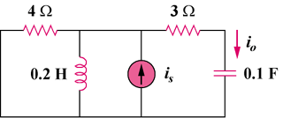

Figure 9.53
For Prob. 9.46.

Solution

Let ,

Thus,
2.325cos(10t + 94.46) A

